Towers of Hanoi
AIM:
To write a Prolog program to solve the Towers of Hanoi problem using recursion.
ALGORITHMS:
- Start.
- Read the number of disks $N$.
- If $N=1$, move the disk from the source peg to the destination peg.
- Otherwise:
  - Move $N-1$disks from the source peg to the auxiliary peg.
  - Move the remaining disk from the source peg to the destination peg.
  - Move $N-1$disks from the auxiliary peg to the destination peg.
- Stop.

CODE:
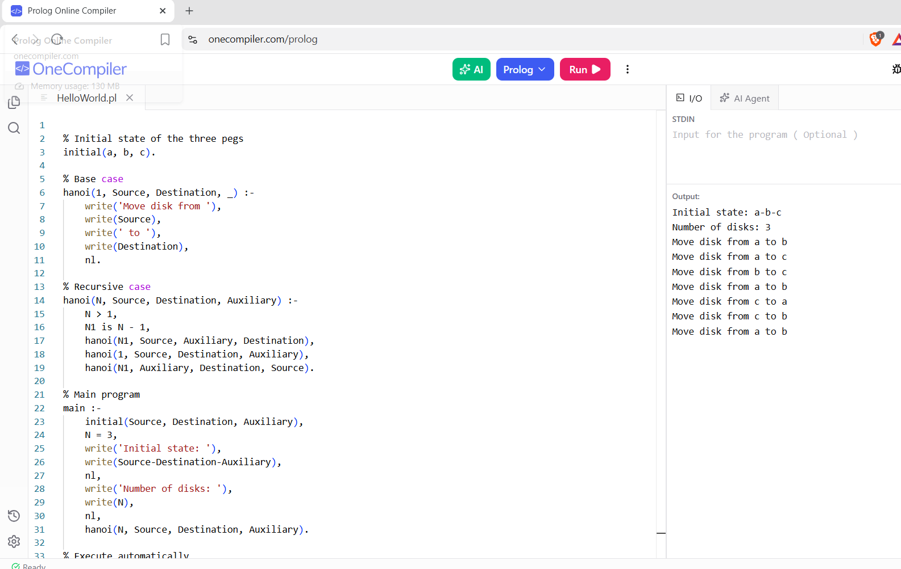

RESULTS:
The sequence of moves required to solve the Towers of Hanoi problem is generated successfully.

